

Now we’ve got a set and a script, we need some voices! For this session, me and +CHILDNAME+ explored bringing our script to life!

If countless hours of watching their favourite YouTubers have taught them (and especially yourself after hearing the screeching) is that alongside the visual content, audio is paramount!

That's why we brought in some awesome headsets, sporting multicolored LED lighting in true gamer like fashion to capture +CHILDNAME+ ‘s compelling story. We began by recording whatever thoughts or stories came into +hisher+ head. Being able to help record thoughts, share a familiar story or even rehearse our new script is a great way to help build confidence on the microphone.

As much as we may want, our first takes are rarely one hit wonders, so we need to be patient with the process. This is why storyboarding and scripting is so important as they all factor into our prep work, even if we make some slight changes here or there.

We also explored some voice changing software so +CHILDNAME+ can edit their audio to resemble an alien voice, an echo of a large space, being underwater and everything in between! Fantastic work today superstar!



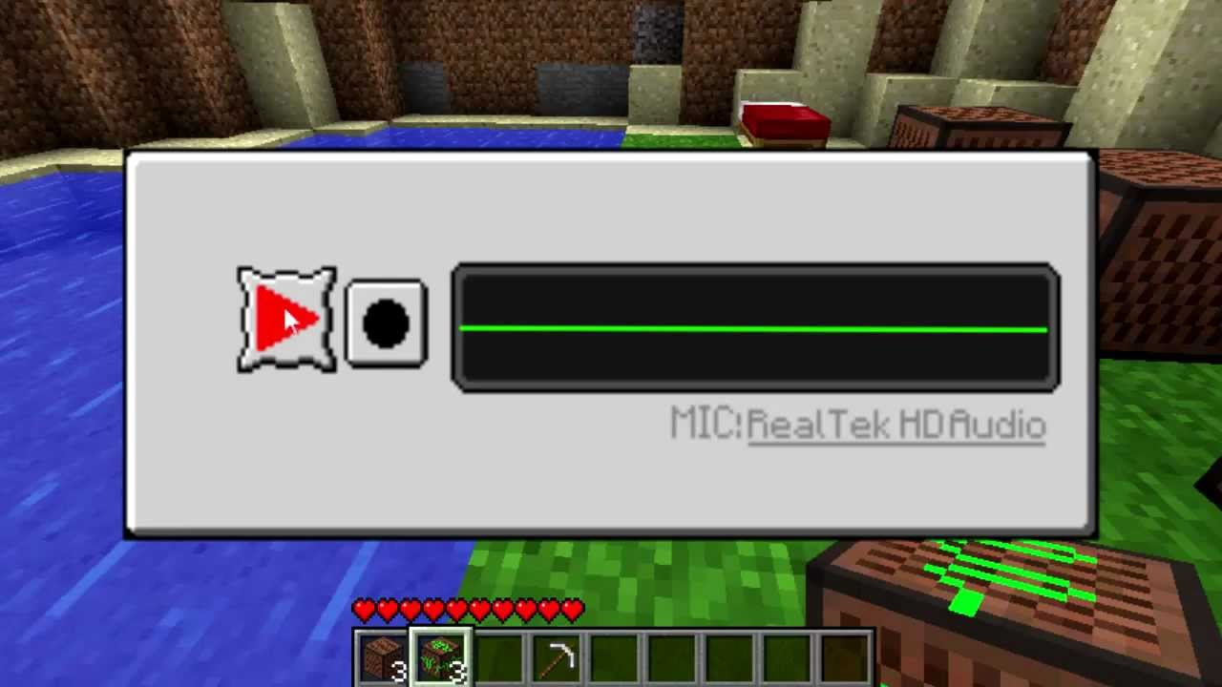

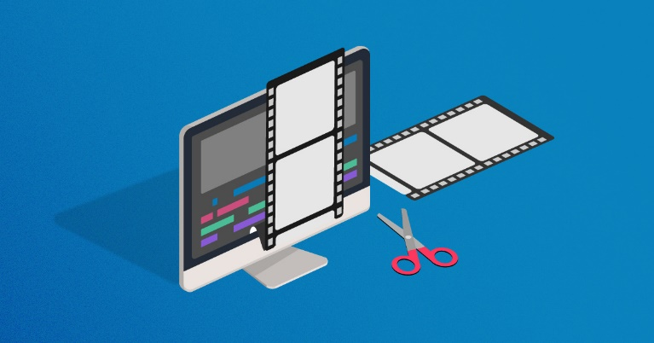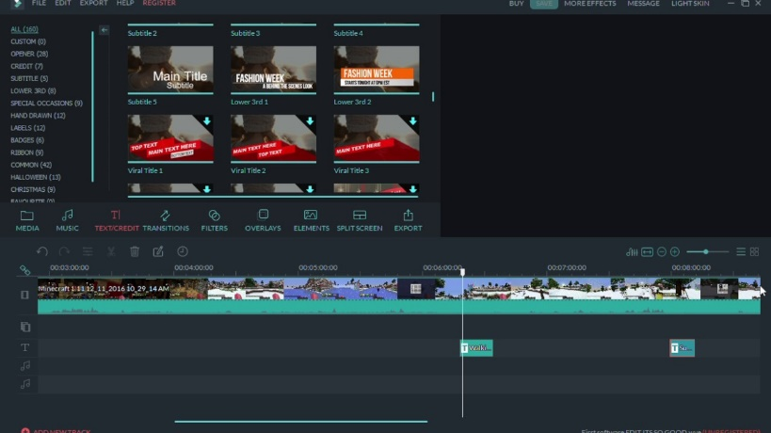



In this session +CHILDNAME+ had to bring everything together to ensure that +hisher+ project was as good as can be!

From multi-million dollar Hollywood projects to stop motion animation filmed in a bedroom, editing and post-production is often known as the real magic of the storytelling process. Here we can rehash ideas, incorporate feedback and ensure the project is visually compelling and as structurally coherent as we originally intended!

We furthered the basics today from having a peek at editing at the beginning of the camp. +CHILDNAME+ was using Windows Video Editor, which is  very accessible tool with a  full-featured set of video creation and editing tools that +heshe+ can use to tell our new story with!

+CHILDNAME+ bolstered the original video with some music, text, motion, and 3D effects! We also clipped and trimmed the footage to create flow and for either a more dramatic or comedic effect.  Combining this focus today with the easy-to-use creative tools, enabled +himher+ with the means to show off a great story!

Amazing stuff superstar, let’s hope not too much golden content was left on the cutting room floor!